Upon choosing the “log in” option on the opening screen of the app or from the create account screen, the user will be brought to a standard login page. Numbered items here are self-explanatory.

1

2

3

4

5

6

(Login Screen – Nathan Sorlien)

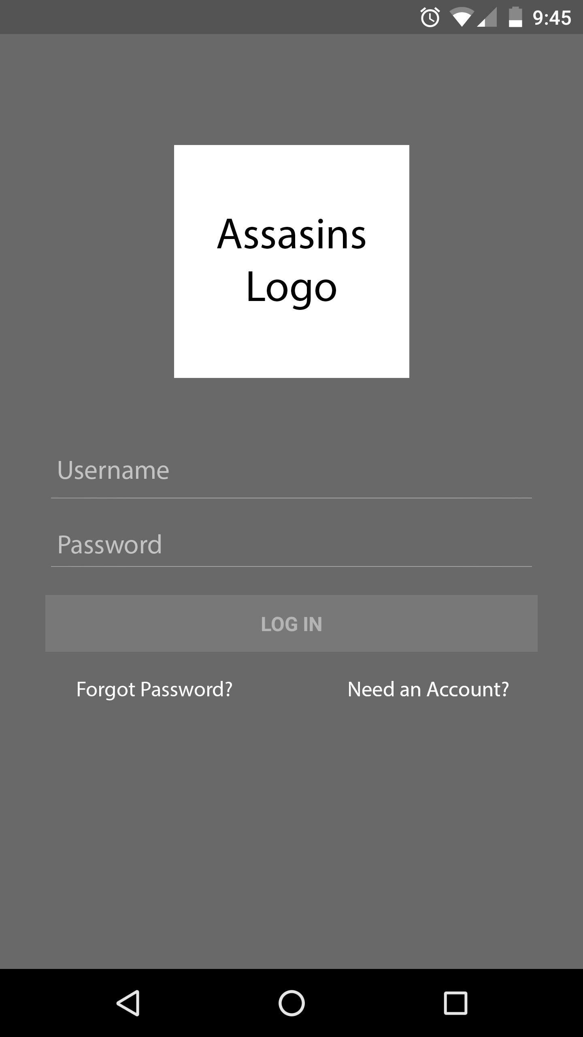

1

2

3

4

5

6

7

8

(Create Account Screen – Nathan Sorlien)

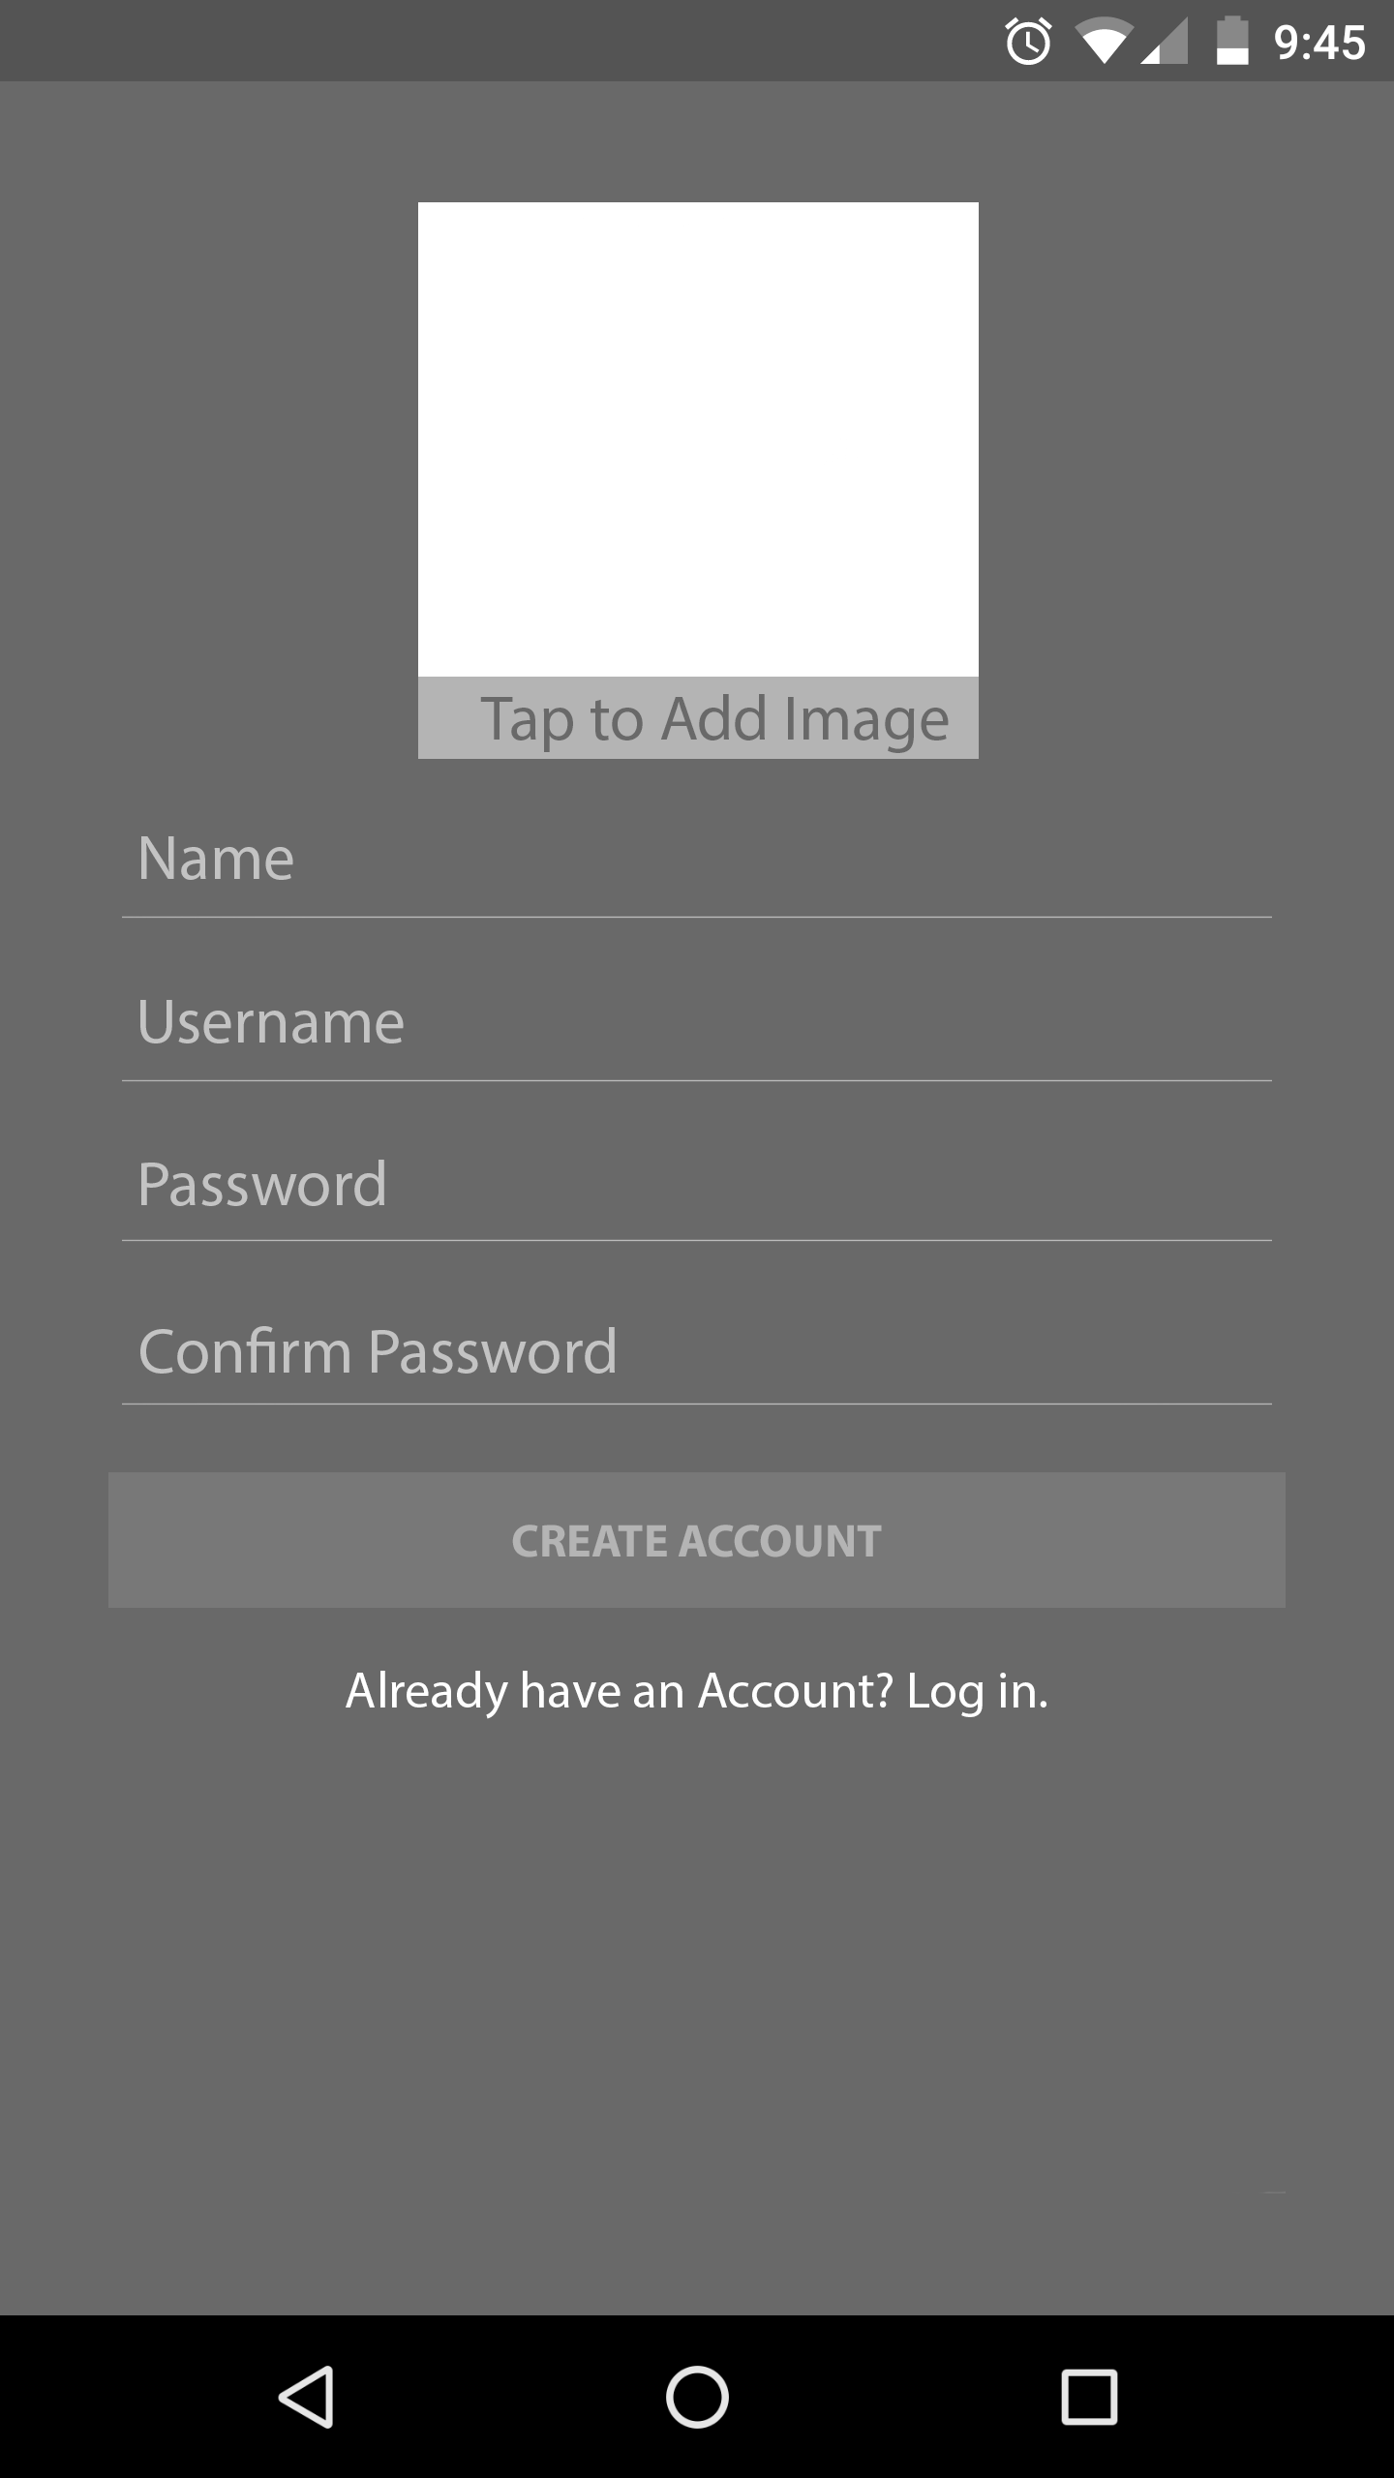

Upon choosing the “Create Account” option from the opening screen or from the login screen, the user will be brought to a standard create account page. At the top, a preview (1) will be shown of an image to be used as the user’s profile picture, which is selected by clicking the text within (2). The rest of the numbered items on the page are self-explanatory again.

(Lobby Screen – Nathan Sorlien)

1

2

3

4

5

6

7

8

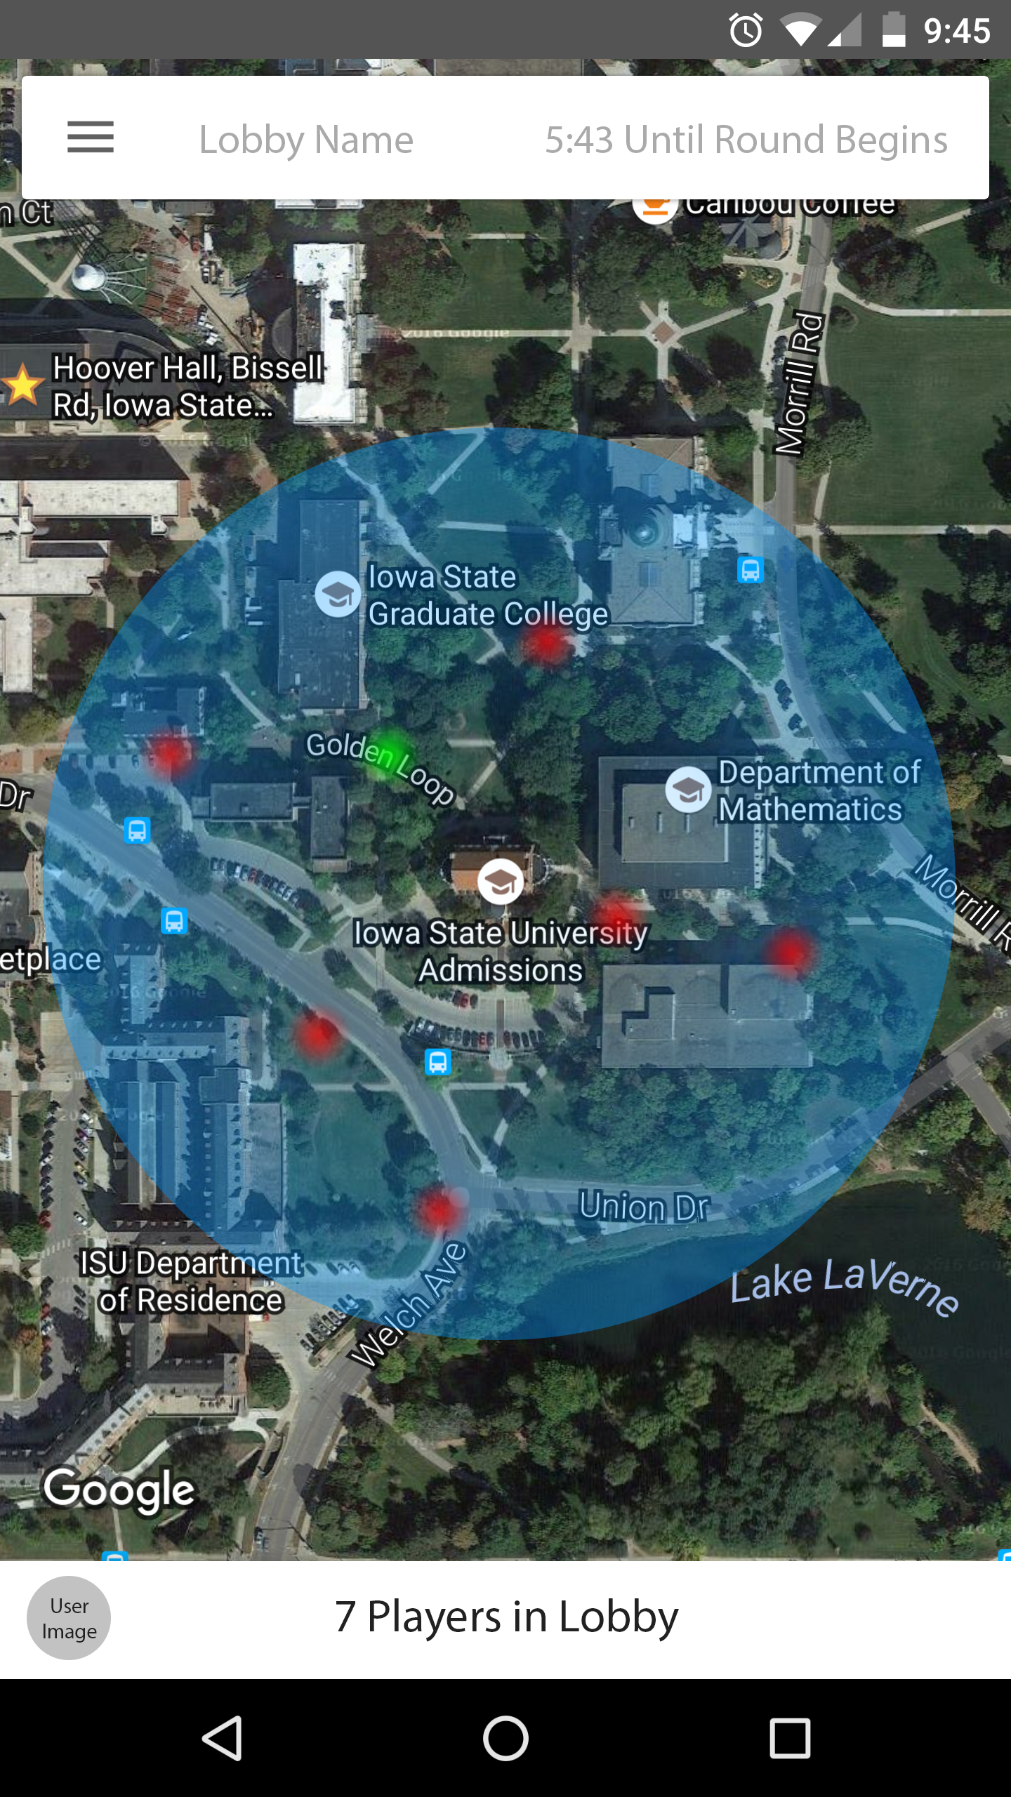

The lobby screen is what the user (location indicated by 6) will see while waiting for a game/round to start. As with most multiplayer games, the lobby screen should provide an overview of the game about to be played. The screen indicates the name of the game/lobby the user has joined (2), the time remaining until the round starts (3), and the playable and surrounding areas of the round (4 and background map). The user is also able to quickly view the various game options selected by the lobby creator (1), and also view the players in the game by their locations (5, etc.) and by tapping on the player count (8), which will expand into a list of all players in the lobby. Tapping their own profile image (7) will bring them to a profile overview with their image, username, stats, etc.